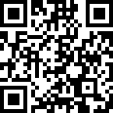

Mouvent AG: Barcode Scanner Identification